
Център за обучение по софтуерно тестване Website: http://skillo-bg.com
Bug Template
Bug ID | TravelSite_B001
Name | Mismatch between Return & Departing date
Priority | P1
Severity | S2
Description
Steps to reproduce | Step1: Open site https://www.phptravels.net  Step2: Choose Flights  Step3: Fill the fields Depart, Return  Step 4. Choose date  Step 5. Choose Adult/Child  Step 6. Choose Round trip  Step 7. Select Search button  Expected result: Shown available flights covered requested date criteria  Actual result: Allows you to choose a return date before the departure date
Attachment | 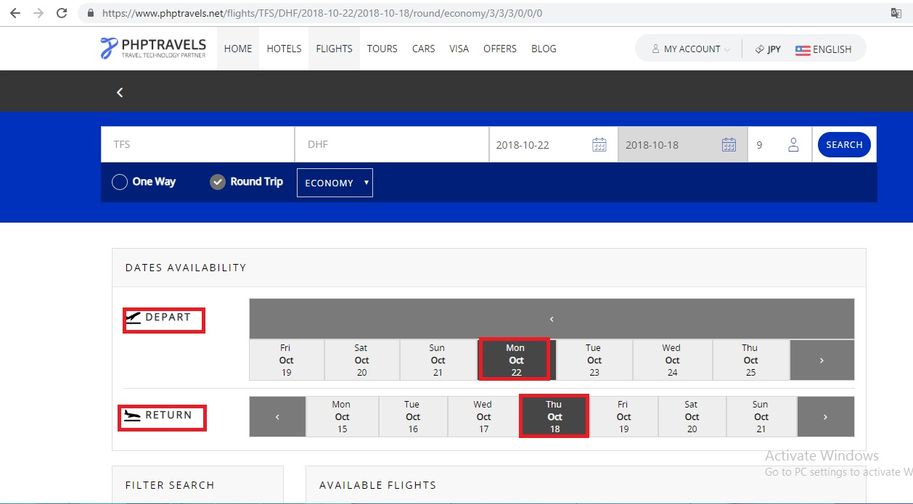
Status | Opened
Component
Version/Build number (Found in)
Environment | Chrome 69.0.3497.100
Comments
Date Created | 10.4.2018
Author | Petya Doncheva
Audit Log

